Step 1: search github in chrome and select the first website in goggle chrome

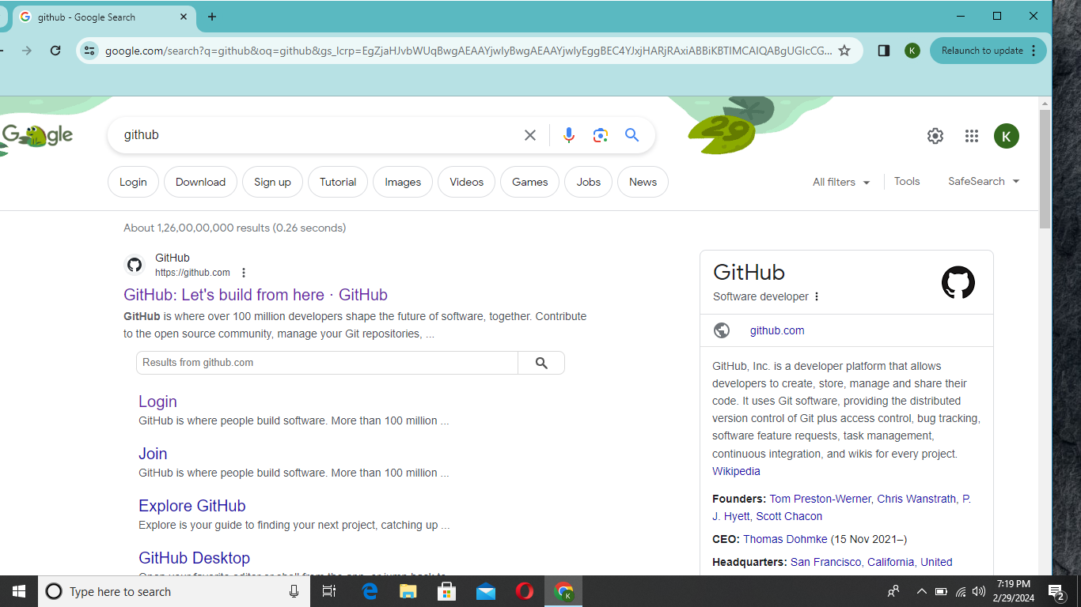

Step 2:Enter on the signup option to create an account on github

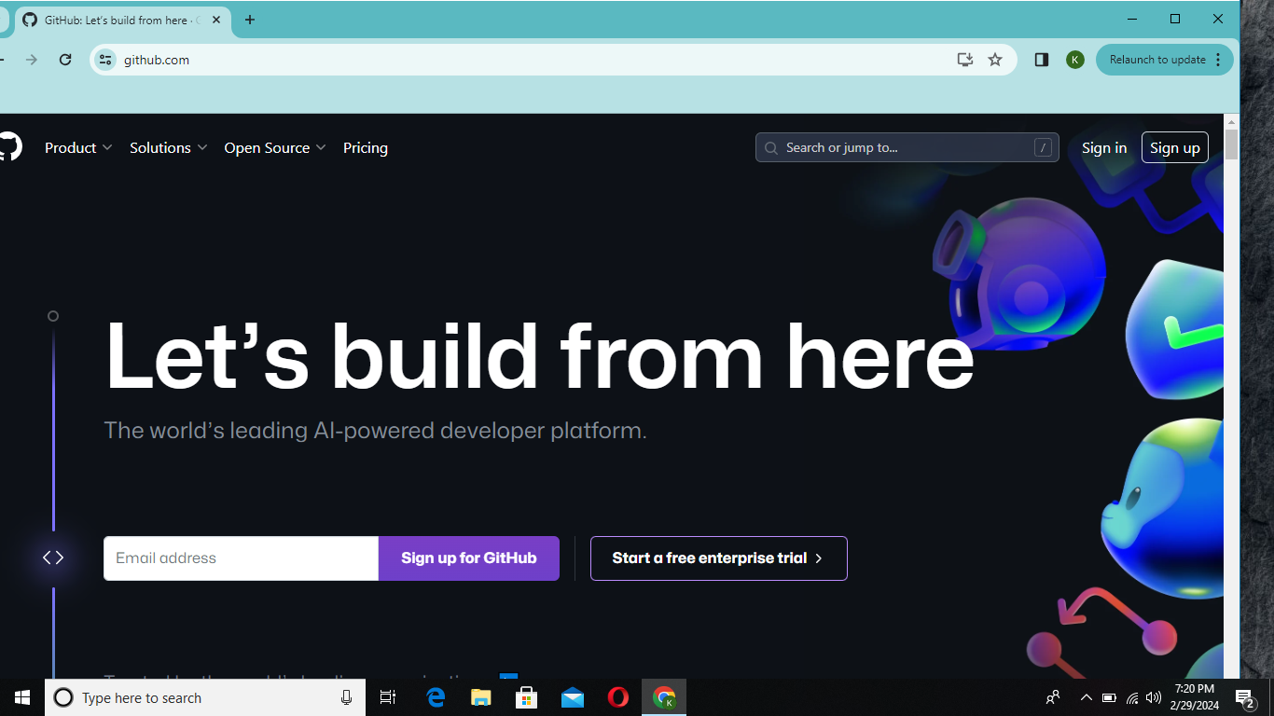

Step 3:

Enter your personal details in sign up form of github to create an account for repository

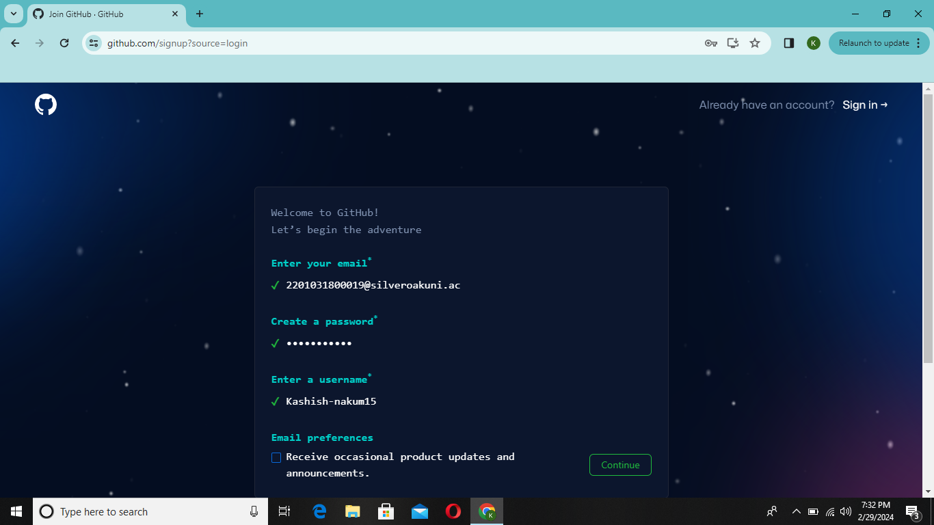

Enter your personal details as needed

Step 4: Enter the launch code which is received in your email id

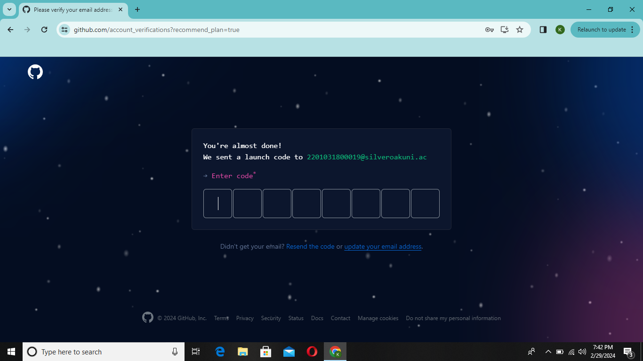

Step 5: select the + option form upper right side to create new repository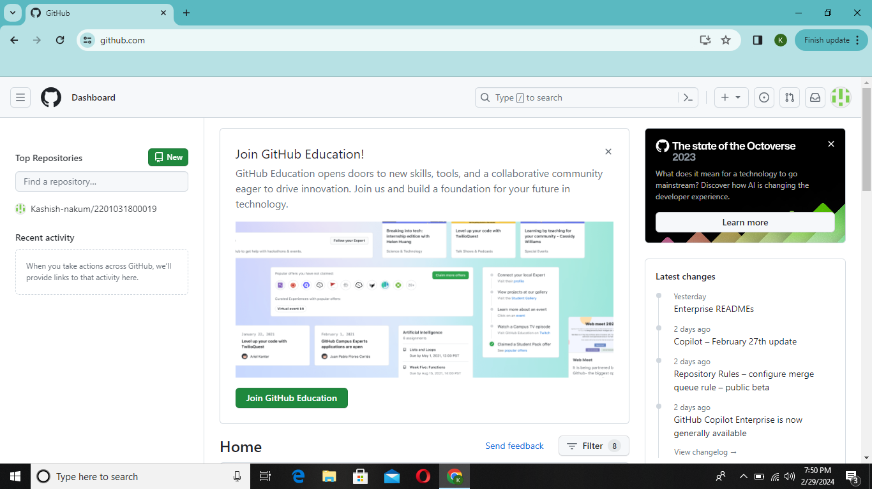

Step 6:

Enter your enrollment no to create a new repositoy

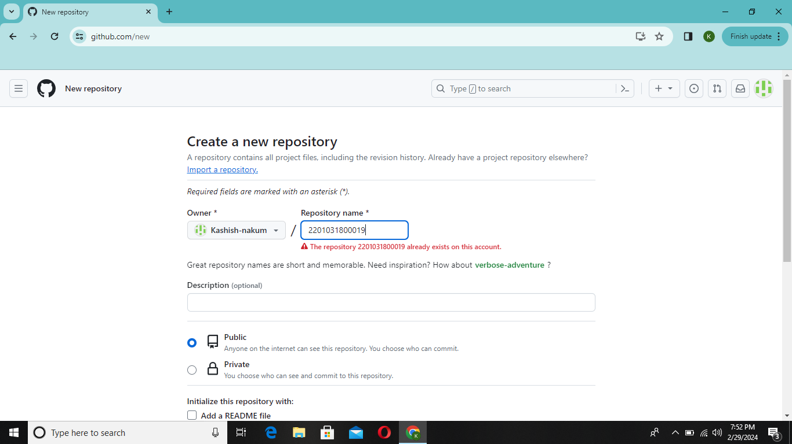

Step 7:select on the create repository option

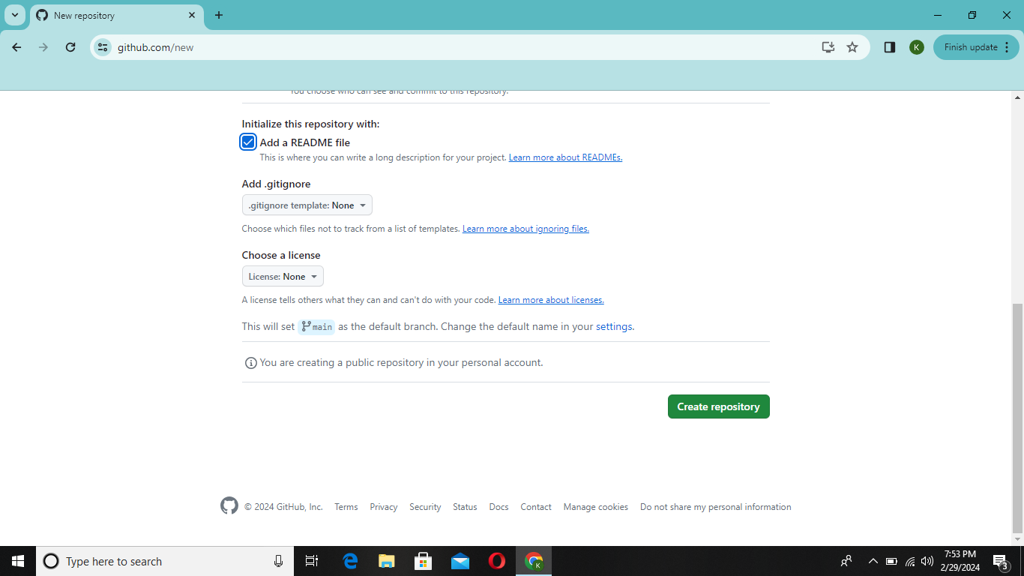

Step 8:

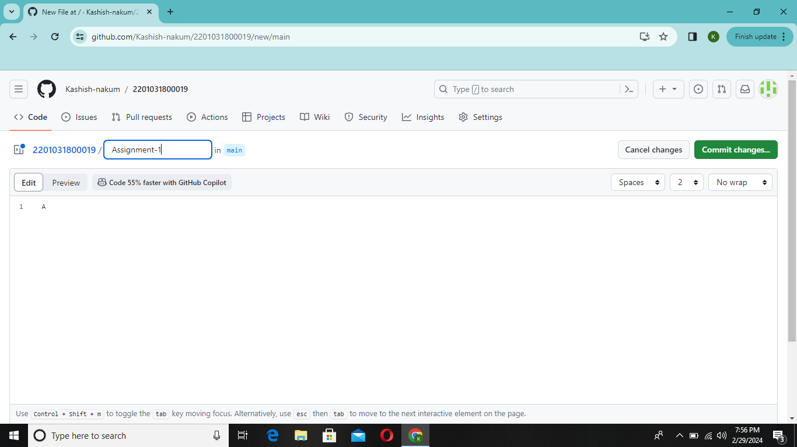

Step 9:create assignment 1 folder and upload your assignment

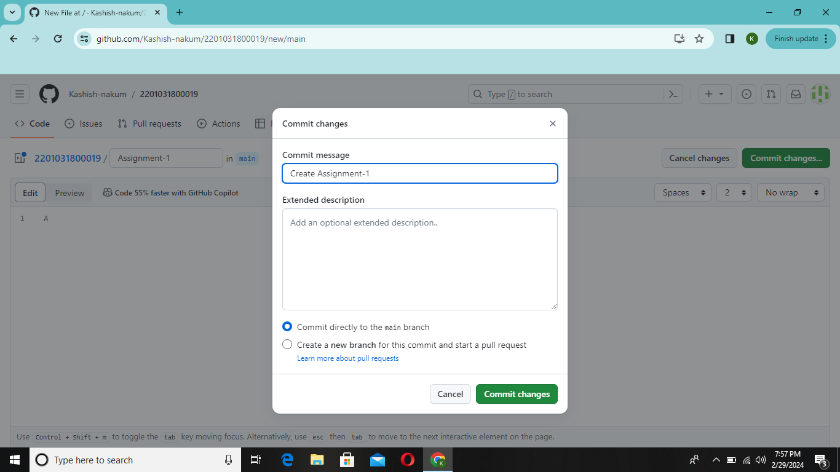

This is how you create your Repository in github

Step 2:Enter on the signup option to create an account on github